PAYMENT INSTALLMENT FLOW – 16.0.1.0

STEPS

1. Go to sale settings and select the ‘single invoice’ setting

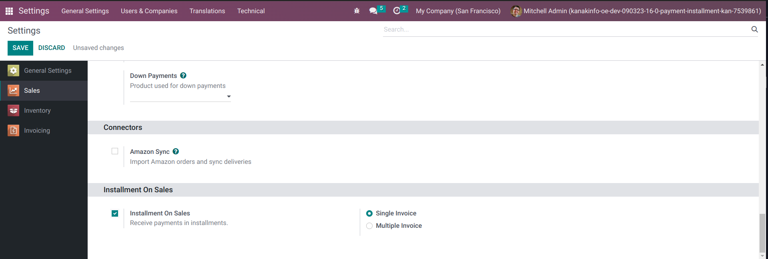

2. Next, go to invoicing > configuration and open ‘payment term / installalment plan’ Here we will make our own installment plan as shown below.

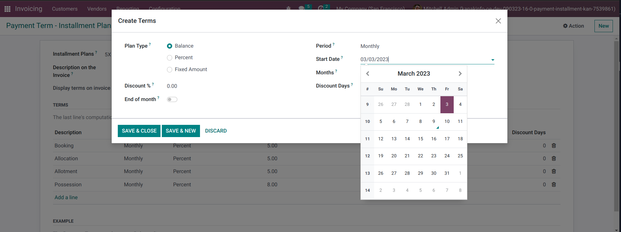
3. The start date is now a datepicker, which makes it easier to set the start date as any month of the year

4. Our new installment plan has been created and is shown below

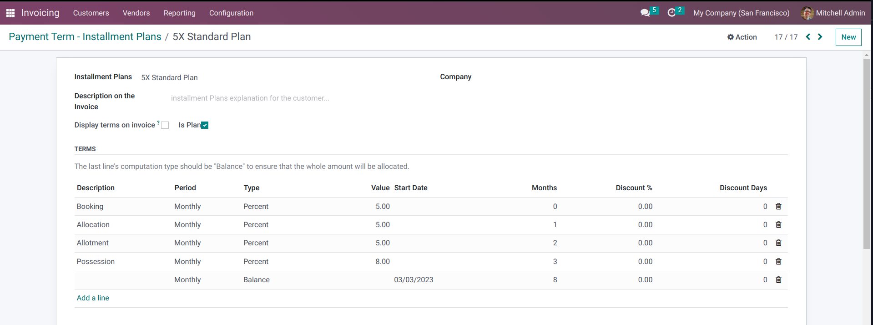

5. Now, go to ‘Quotations’ and create a new quotation. Enter the details and click on the installments tab

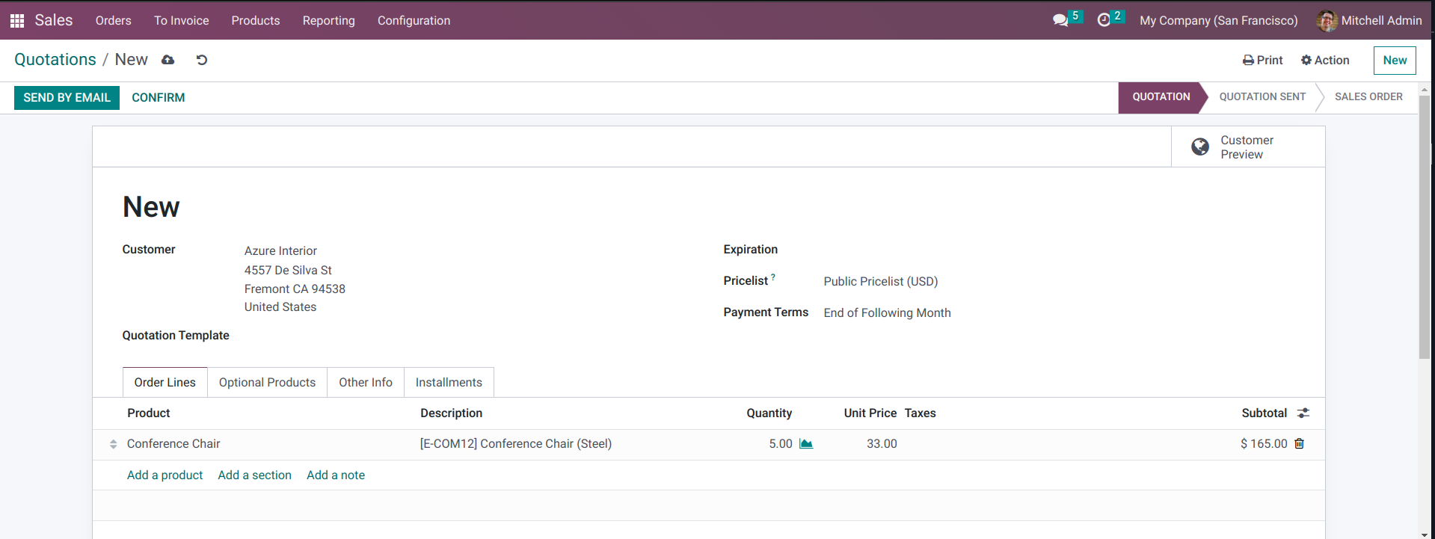

6. Here you can select any installment plan. We have selected the ‘5x standard plan’ , which had just been created in the previous screenshots

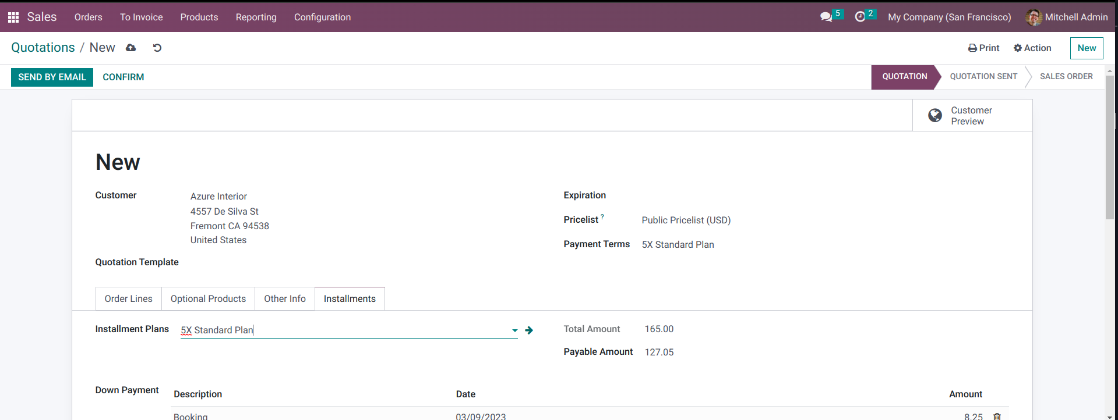
7. All the details of the plan has been displayed and the first installment date is set

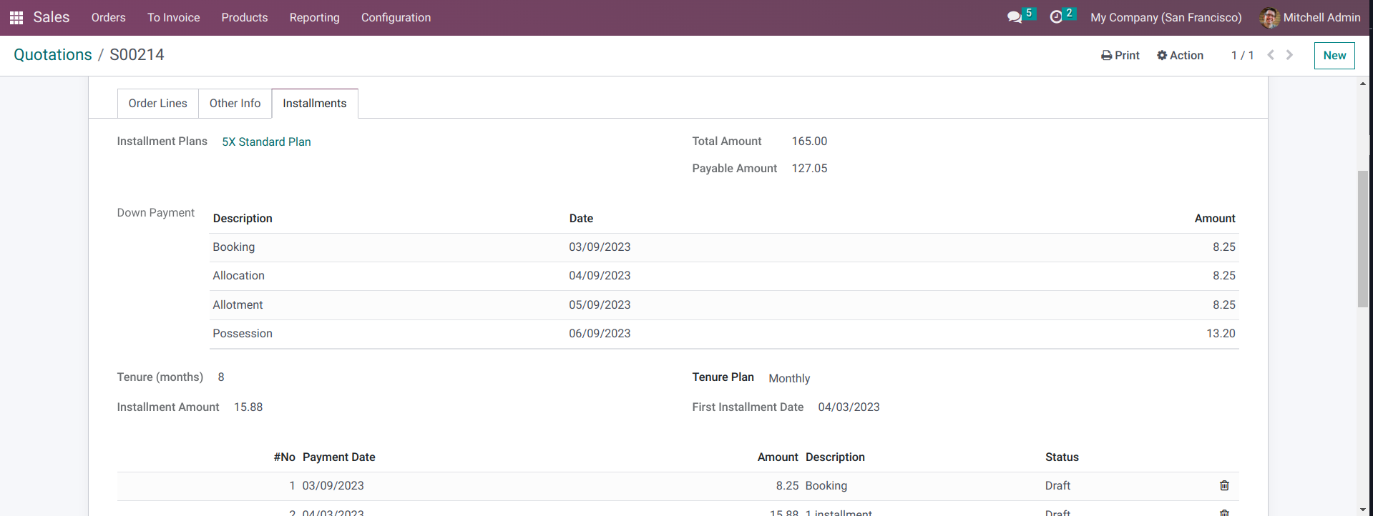

8. The plan data is displayed as shown below

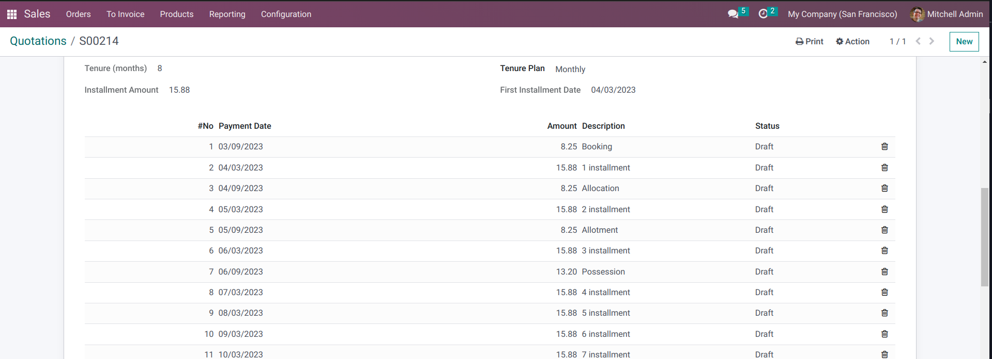
9. Before creating an invoice, we have printed a ‘Sale Installment’ Report from the print option, which has all the plan data as shown below

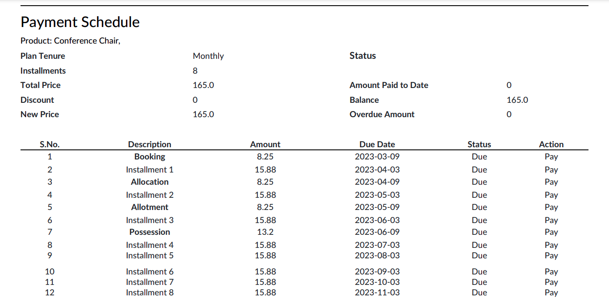

10. Now we will click on the ‘Delivery’ Button and validate the delivery of our order as follows
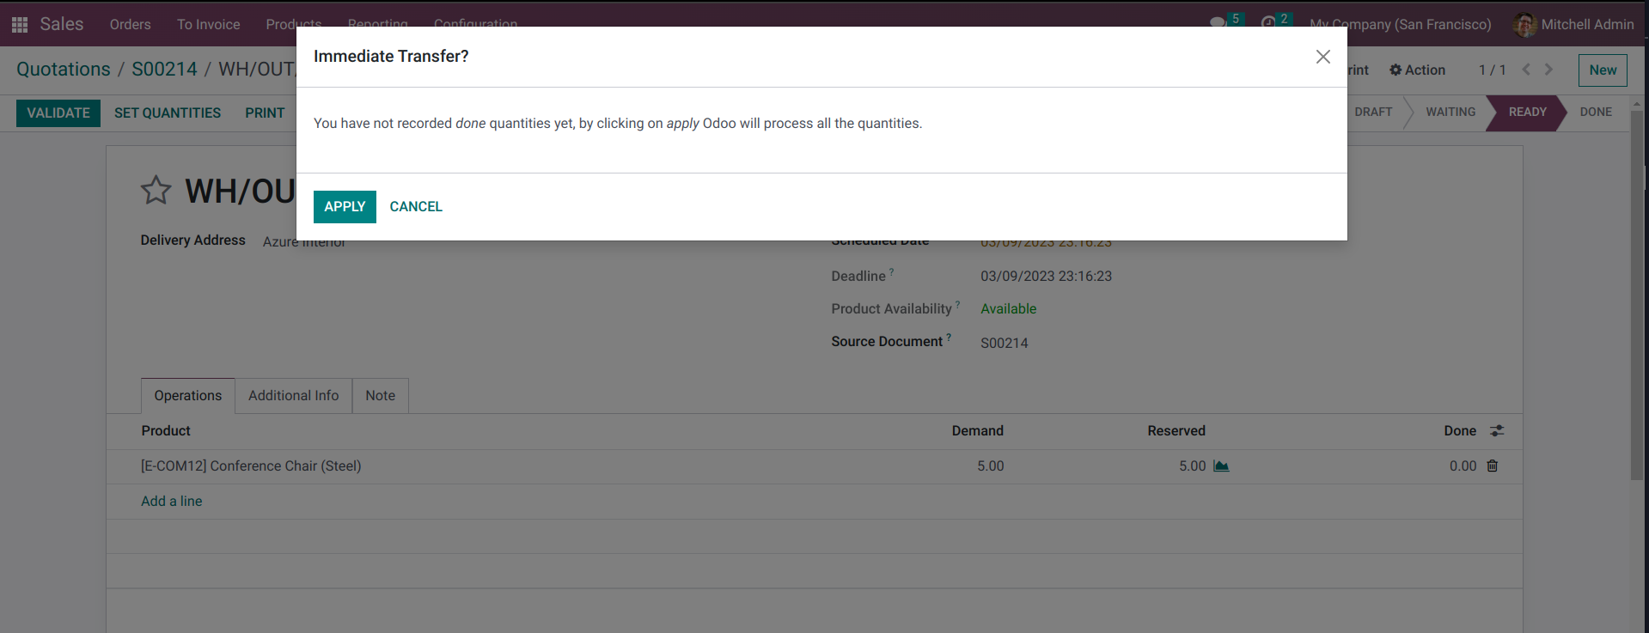

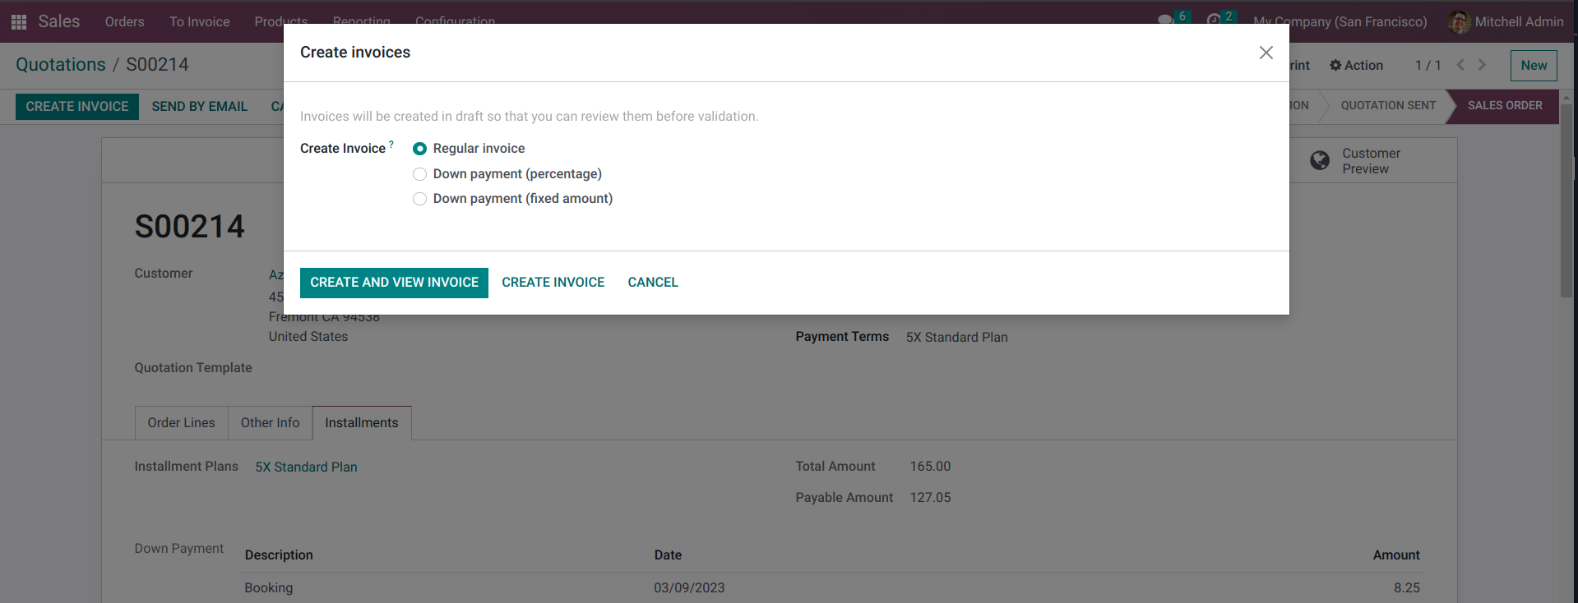
11. Next, we will create an invoice for our order

12. This is the draft invoice. Press on ‘confirm’ button to post the invoice. After the invoice is confirmed, press on the ‘Installments’ tab
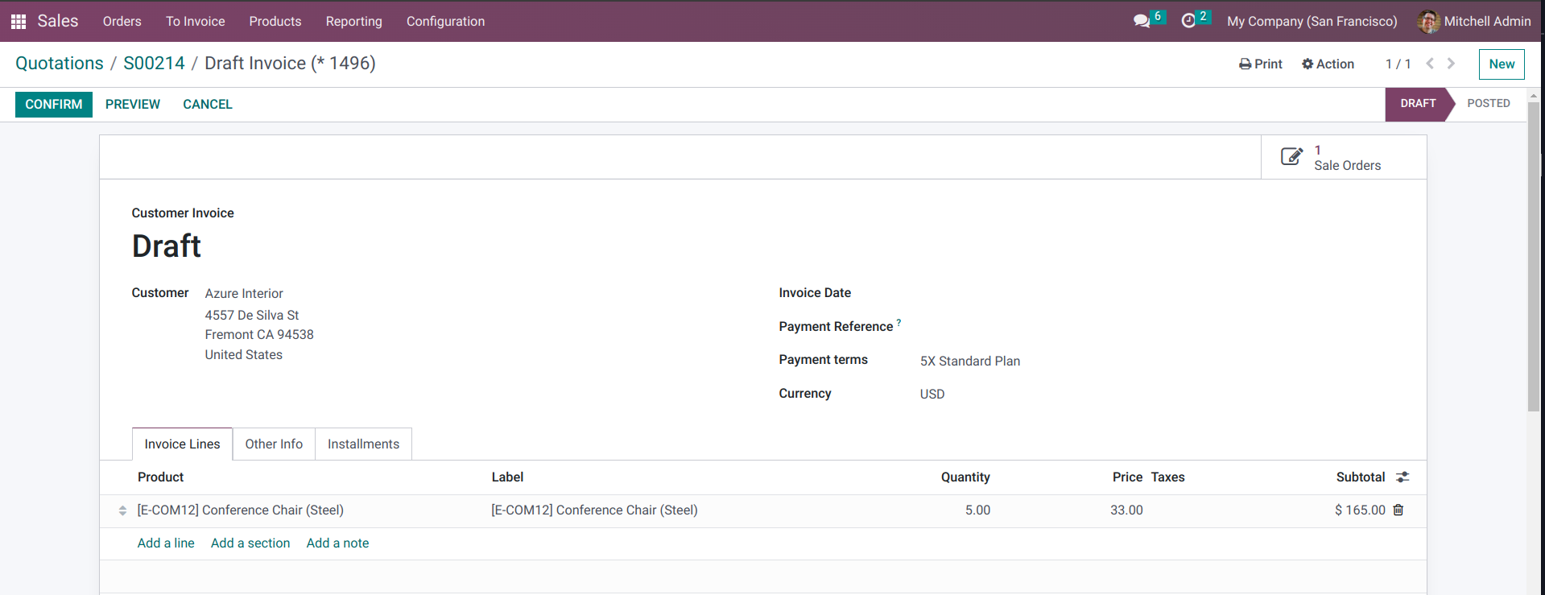

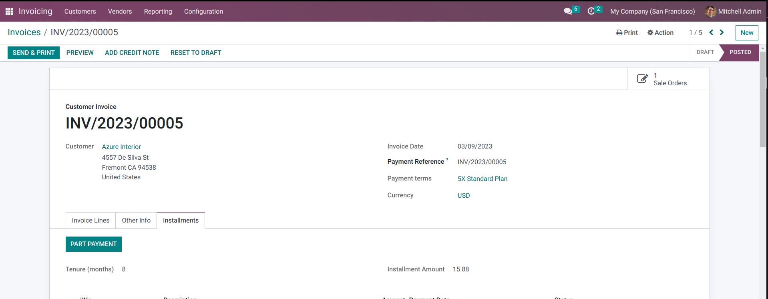

13. From the installment tab, we can pay each installment individually by clicking on the ‘Pay’ option next to the installment line

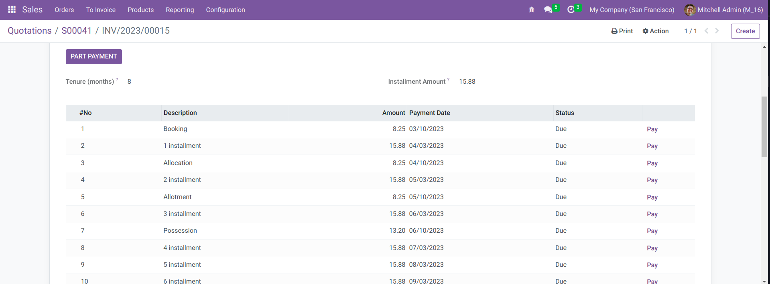

14. After clicking on the ‘pay’ option, select all the details and press ‘Create Payment’ to pay for a particular installment

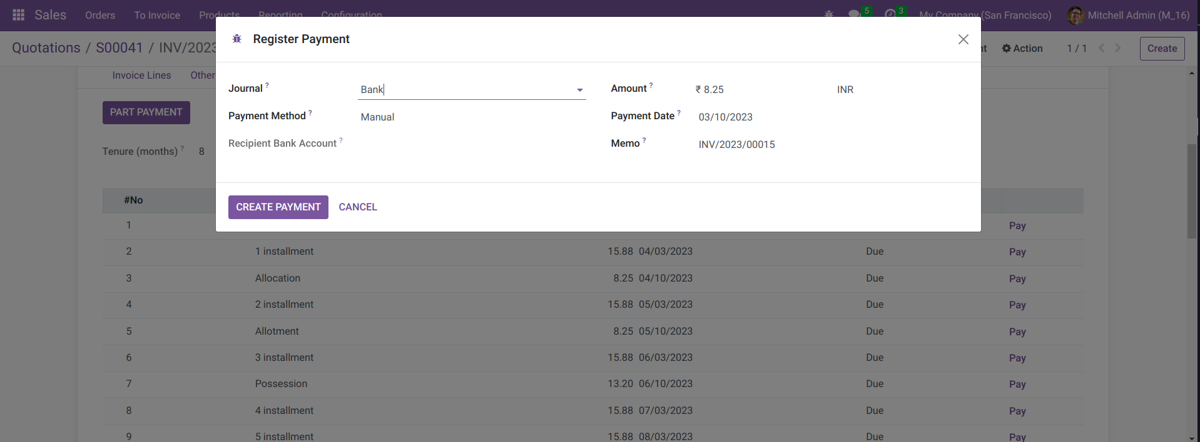

15. The ‘Status’ will be changed to paid when the installment is paid. We have paid for the ‘Booking’ and ‘ 1 installment’ as shown below

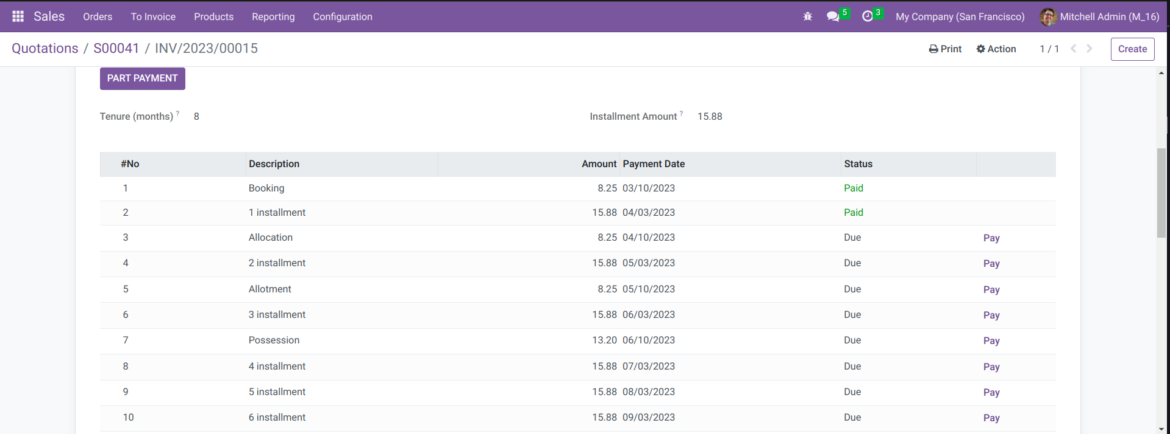
16. Similarly, we have paid till 3 installment and all these changes will be reflected in the ‘Invoice Installments’ report

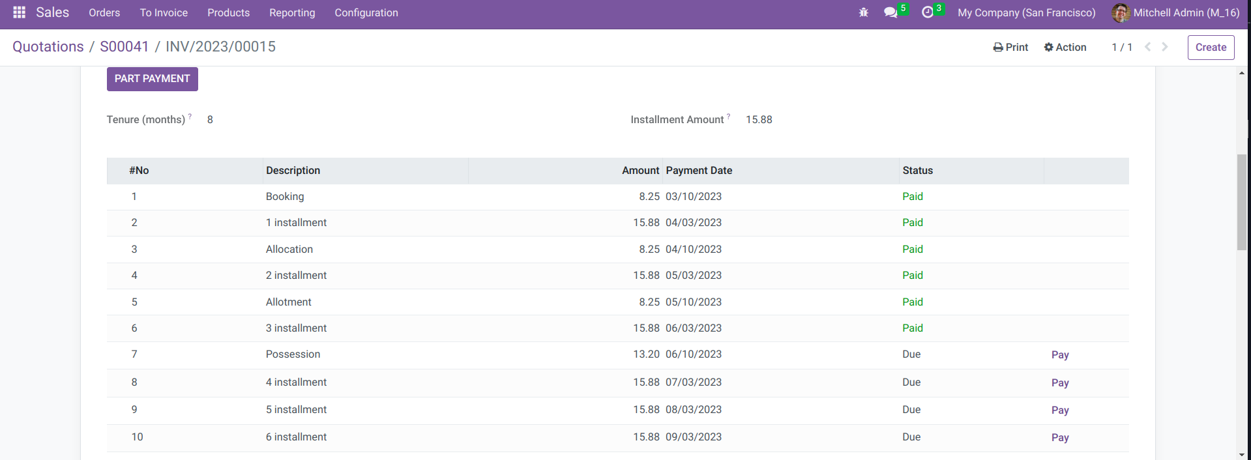
17. Now we will click on the ‘ Part Payment’ Button and create a part payment for ‘Possession’ , ‘4 installment’ and ‘5 installment’ and click on ‘Confirm’

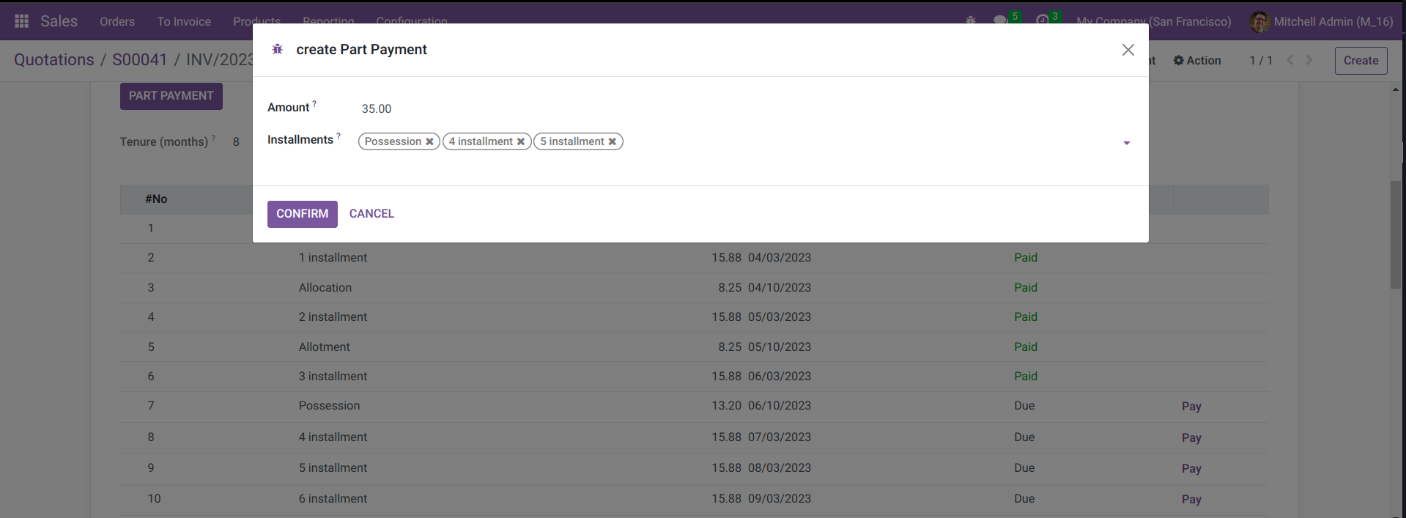

18. As show below, our payments have been reflected in the installment data

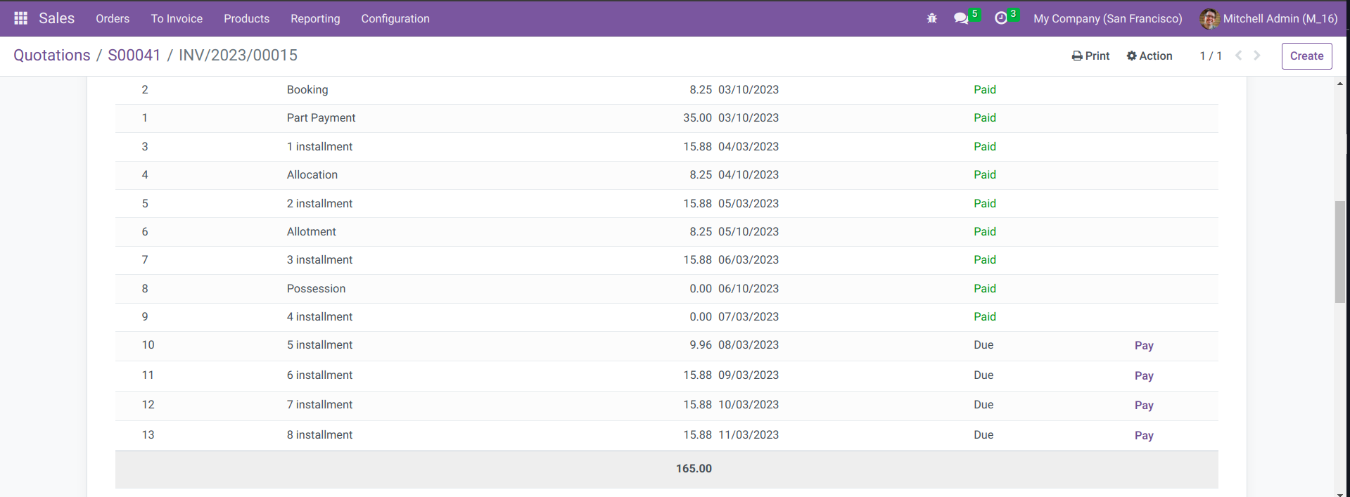

19. Next, we will download the ‘Invoice Installments’ Report and the ‘installment 5’ will be a ‘Partial’ since it has not been fully paid. The ‘Invoice installments’ report is shown below

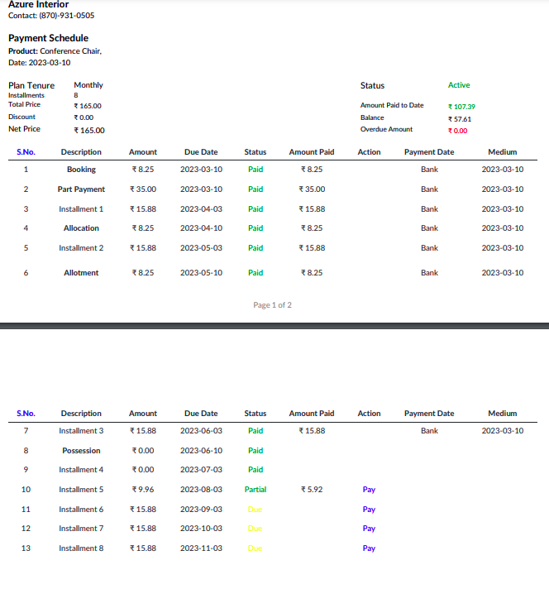

20. After the payment, the invoice will be marked with a ‘Partial’ badge , indicating that the installments have been partially paid

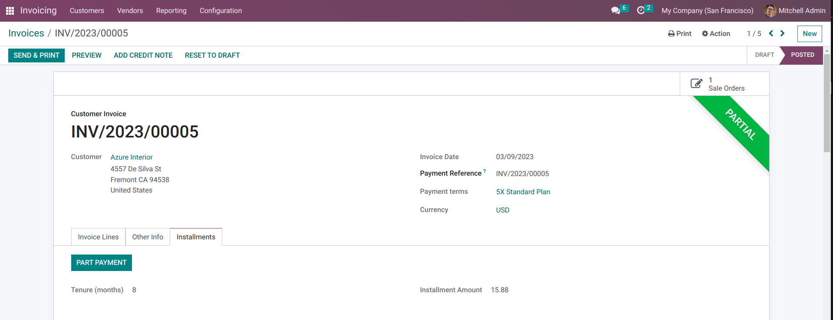

21. That’s it for the single invoice. Now we will go back to the sales settings and select the ‘Multiple Invoice’ Option, as well as select the number of days before the invoice is created. Save the changes and refresh the page

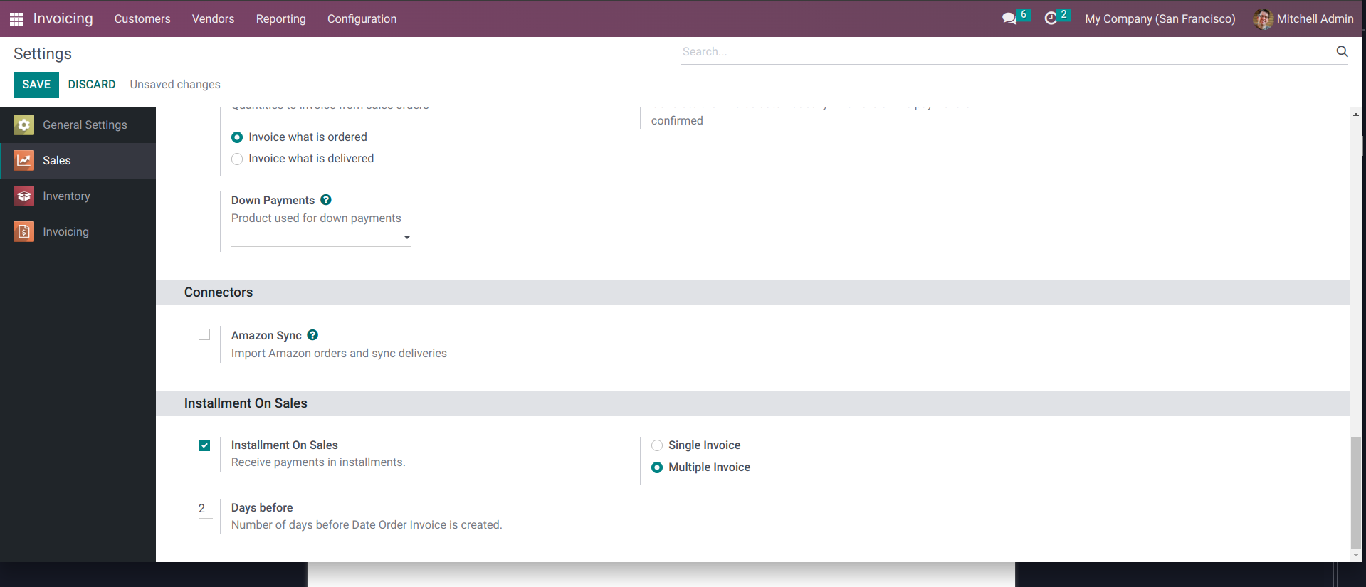

22. Now we will create a new quotation, similar to how we created it for the ‘single invoice’

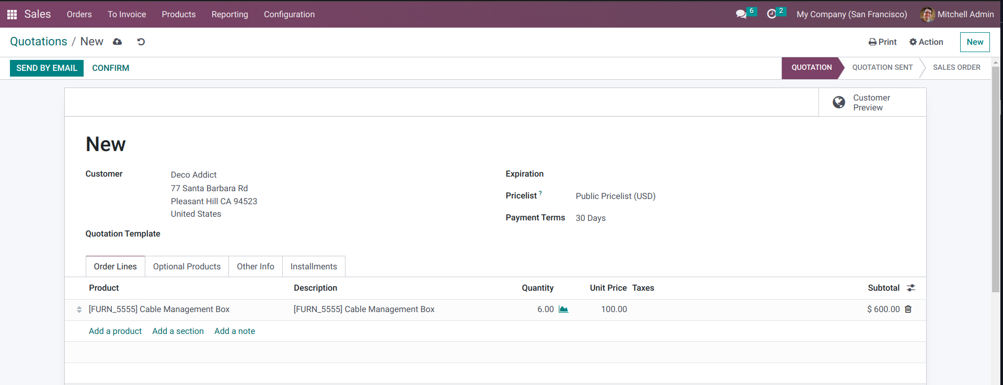

23. Once more, select the ‘Installment Plan’

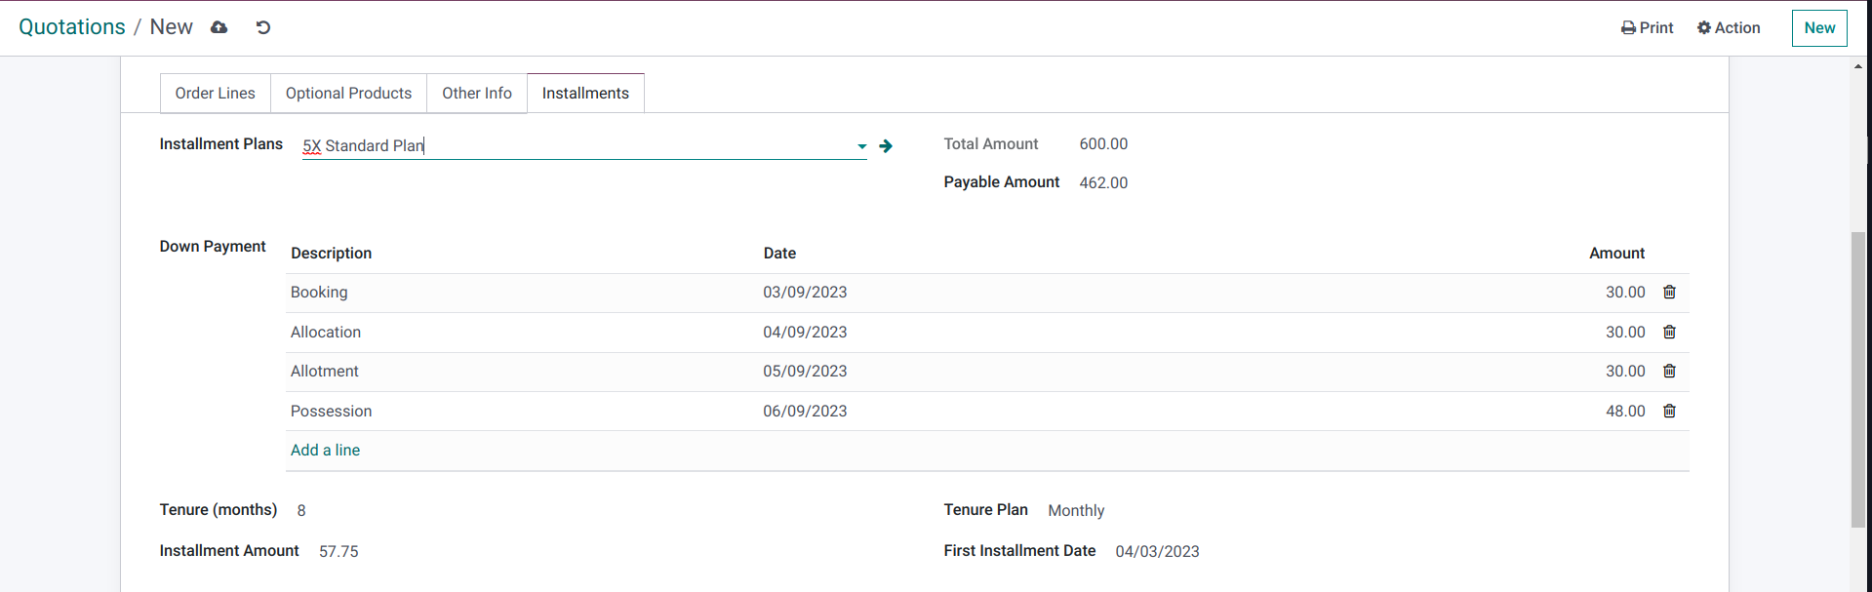

24. Click on ‘Confirm’ and validate the order by pressing on ‘Delivery>Validate’
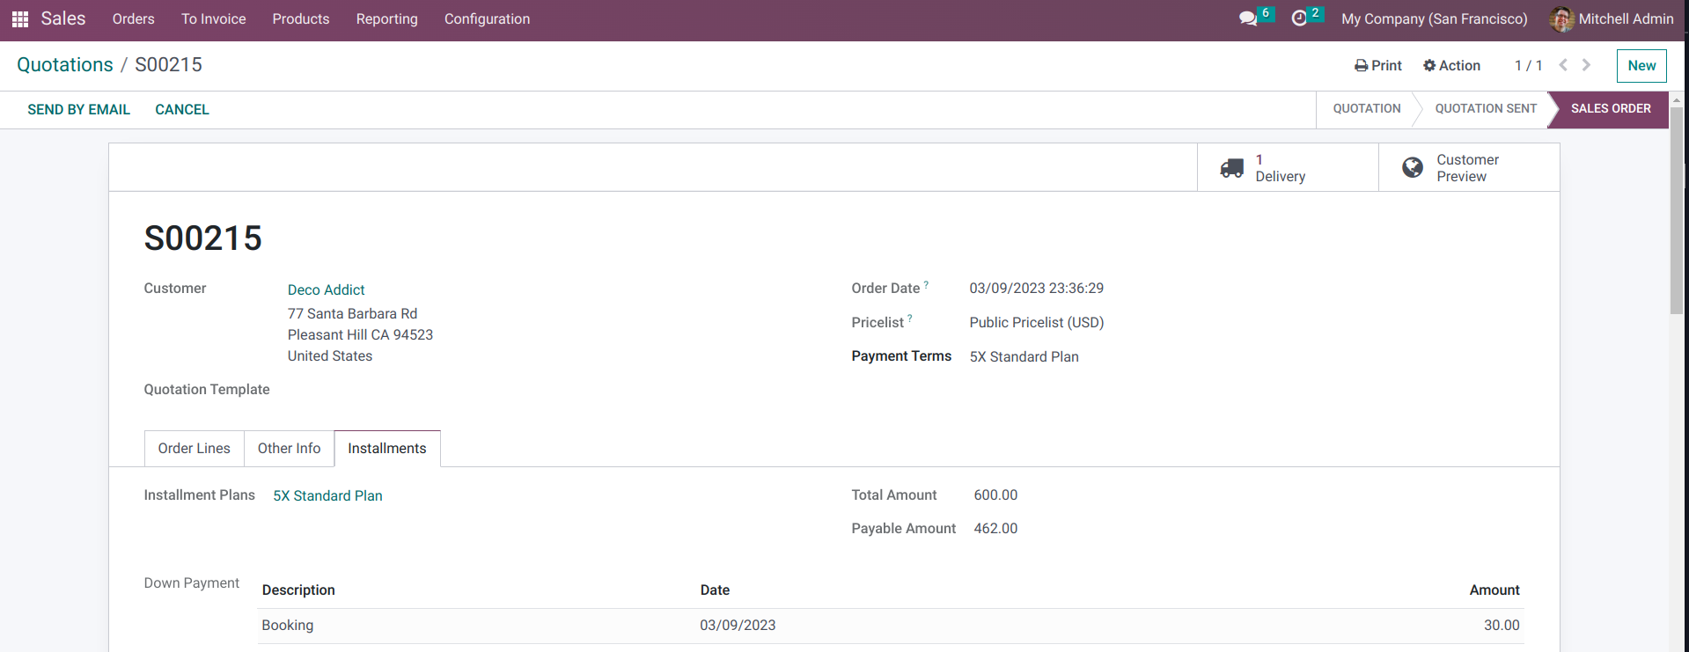
25. Create an invoice for the order

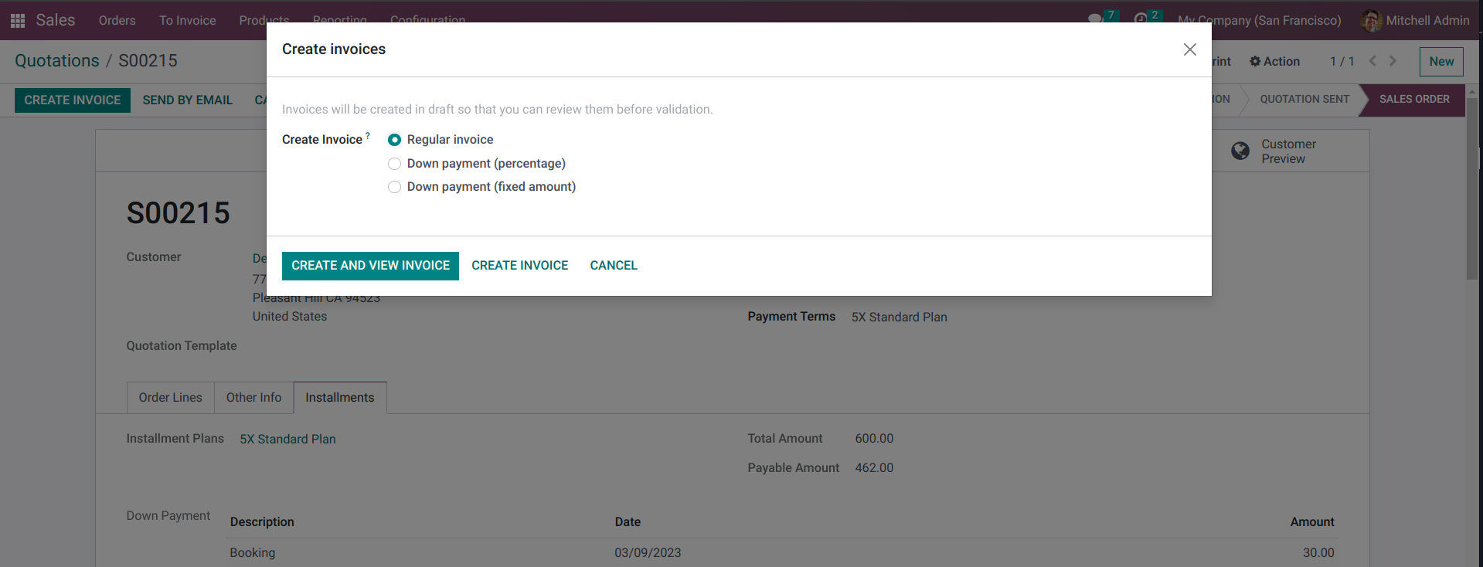

26. Confirm the invoice and the ‘Installment’ option will not be available as this is a ‘multiple invoice’ which means that all the installments will have a single different invoice. The ‘Invoice Installments’ Report option is also not available for multiple invoice.

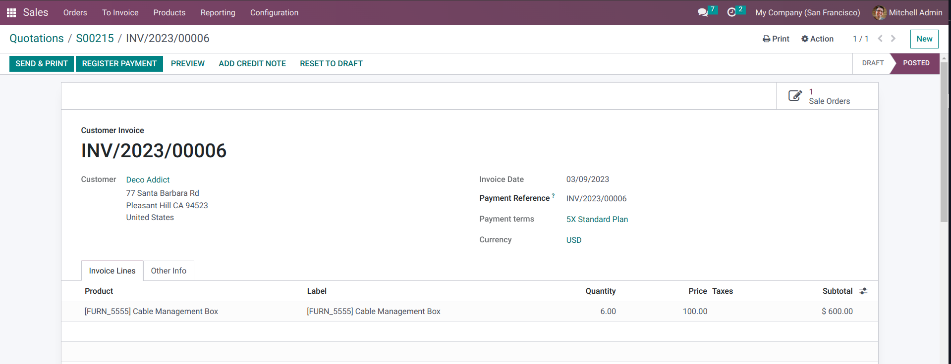

27. To print a report for this invoice, click on ‘Print’ and select ‘Invoices’. This will generate a report as shown below

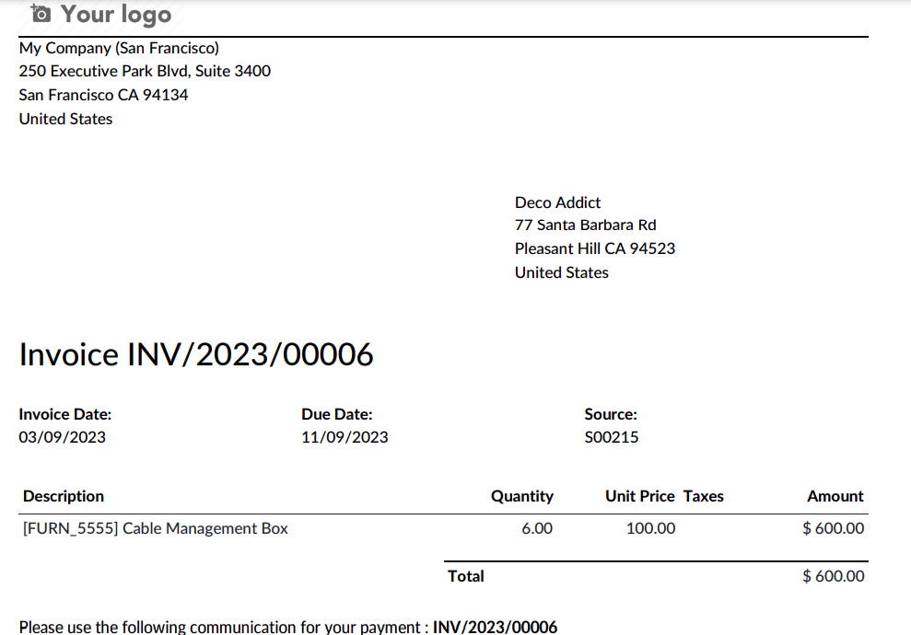

28. A scheduled action for installment reminder is created. The reminder mail will be sent to the customer some days before the paymend date. The days can be specified in the settings, next to the ‘multiple invoice’ option.

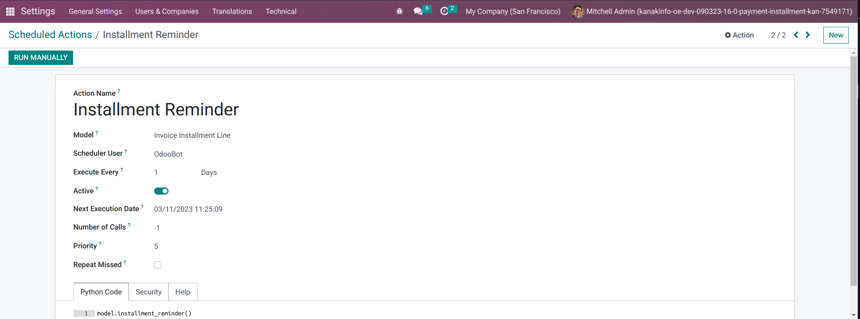

Please check the Improvements and fixes on the next page

IMPROVEMENTS

Issue 1 :

Solution : We have added a datepicker ‘Start date’ so that it is easier to start the installment from any month of the year. This will provide flexibility to the user.

Issue 2 :

Solution :

The installment Tab is still visible for the invoice if the ‘single invoice’ setting is selected. This is shown in the screenshot below.

However, if ‘multiple invoice’ setting is selected, then the Invoice tab is hidden, as this is a part of the functionality.
Figure 1: Single invoice setting selected

\
Figure 2: Multiple invoice setting selected

Issue 3 :

Solution :

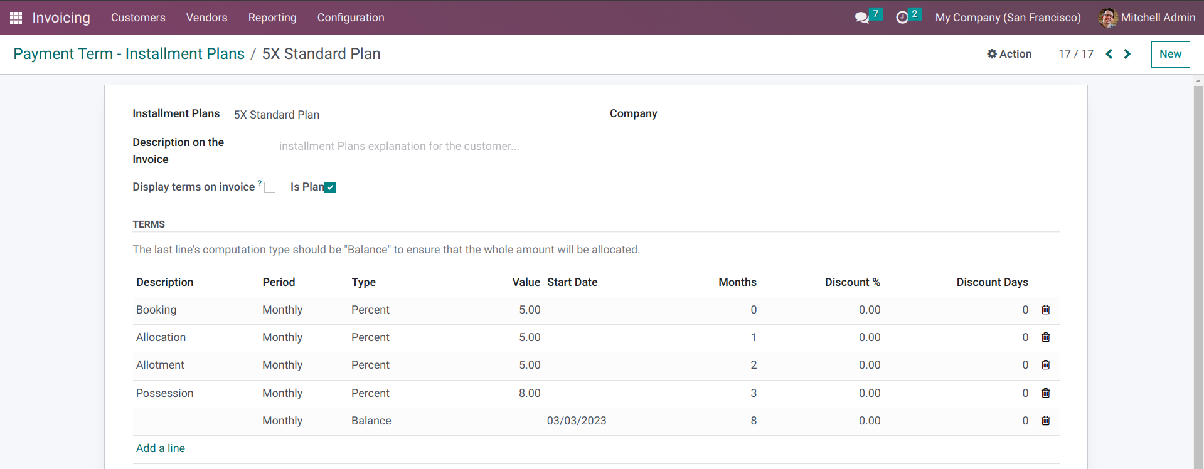

These columns can not be re-arranged as they are a part of the odoo default addons

Issue 4 :

Solution :

The PDF is populating the plan data in case the ‘single invoice’ setting is selected as shown below

Figure 3: Single invoice setting selected

However, if ‘multiple invoice’ setting is selected, the pdf will not be generated in a similar fashion as this is a part of the functionality. Instead, we will be able to generate an ‘Invoices’ Report under the ‘print’ option.

Figure 4: Multiple invoice setting selected

